**Classroom Activity​-Write a program to Check the Grade by using a Switch Case ​**

**Eg .for students 90-100 A grade​**

**for students 80-90 B grade​**

**for students 70-80 C grade​**

**Code:**

let marks = 85; // You can change this value to test with different marks

let gradeRange = Math.floor(marks / 10);

let grade;

switch (gradeRange) {

case 10:

case 9:

grade = "A grade";

break;

case 8:

grade = "B grade";

break;

case 7:

grade = "C grade";

break;

default:

grade = "No grade";

}

console.log("The grade is: " + grade);

**Output:** 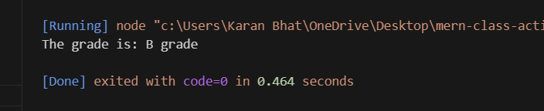

**Execution Steps:**

* Create a JavaScript file with any name
* Write the code
* And run the code in the terminal using F5 or right click and go to inspect and you can get the output in the console as well.